Lambda Functions in Python
What is a Lambda Function?
- A tiny, anonymous function created using the lambda keyword.
- Unlike regular functions (def), lambdas are used for short, one-time operations.
- They do not need a name, making them quick and efficient
Here are the proper syntax and examples for Lambda functions in Python

1. Lambda vs Regular Function (Squaring a Number)
Syntax
lambda x: x * x
- lambda – Keyword to define the function.
- x – Input argument.
- x * x – Expression that calculates the square of x.
Example
Regular function
def square(x):
return x * x
Equivalent lambda function
square_lambda = lambda x: x * x

print(square_lambda(4)) # Output: 16
✅ Lambda saves space by performing the same task in one line.

2. Lambda Function with Multiple Inputs (Adding Two Numbers)
Syntax
lambda x, y: x + y
- x, y – Input arguments.
- x + y – Expression that adds both numbers.
Example
# Regular function
def add(x, y):
return x + y

# Equivalent lambda function
add_lambda = lambda x, y: x + y

print(add_lambda(3, 5)) # Output: 8
✅ Short & direct compared to defining a full function.

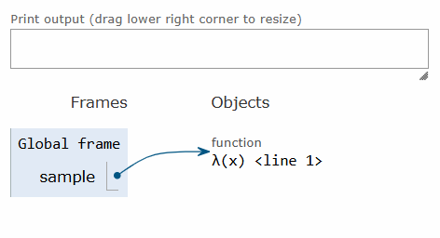

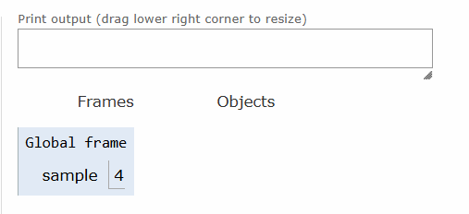

1.if we assign a function expression as a value/object to any variable
2.if we pass a function expression as an argument to the other function
3.if a function returns another function
4.if u add a function as a list element

Then function can be said to be as a first-class function

1.function without parameters
2.with parameters(with positional arguments)
3.with default parameters
4.arbitrary arguments (*args)
5.keyword arguments
6.arbitrarykeywordargs(**kwargs)
7.lambda functions
8.defintion if firstclass functions
9.recursive function
RAMCHARAN-INCASE IF WE KNOW HIM IN TOLLOWOOD,KOLLYWOOD,BOLLYWOOD
GLOBAL STAR-HE IS HAVING SCOPE IN GLOBAL CINEMA
MEGAPOWERSTAR-HE IS HAVING ONLY SCOPE IN TOLLYWOOD CINEMA
HE IS HAVING DUAL SCOPE-ENCLOSING SCOPE

SCOPES-GLOBAL,LOCAL AND ENCLOSED SCOPE,built-in scope

